**Supplementary Material:**

**Supplementary Table S1:** Result obtained from SiteMap analyses of the PDB structures of apo-proteins used during the present study. The predicted ligand-binding sites with their respective site scores and D score

|  |  |  |  |  |
| --- | --- | --- | --- | --- |
| **Protein Name**  **&**  **PDB ID** | **Site name** | **Site Score** | **D Score** | **Volume** |
| LasA  (PDB ID: 3IT5) | Site 1 | 0.930 | 0.935 | 201.684 |
| Site 2 | 0.697 | 0.382 | 60.711 |
|  |  |  |  |  |
| LasI  (PDB ID: 1RO5) | Site 1 | 1.011 | 0.870 | 301.840 |
| Site 2 | 0.739 | 0.744 | 75.117 |
| Site 3 | 0.642 | 0.560 | 65.856 |
| Site 4 | 0.636 | 0.446 | 80.262 |
|  |  |  |  |  |
| LecA  (PDB ID: 4LJH) | Site 1 | 0.588 | 0.375 | 45.619 |
| Site 2 | 0.580 | 0.25 | 37.730 |

* **Site Score** is a numerical value that indicates the likelihood of a binding site on a protein being occupied by a ligand.
* **D Score** is a quantitative measure of the ease with which a protein binding site can be targeted by small molecules.
* Site Score and Druggability score (Dscore) were the two metrics used to evaluate the suitability of a binding site for ligand binding.

**Supplementary Figure S1:** Graphical representation of the docking poses of bromoageliferin bound target protein complexes based on the highest binding affinity.

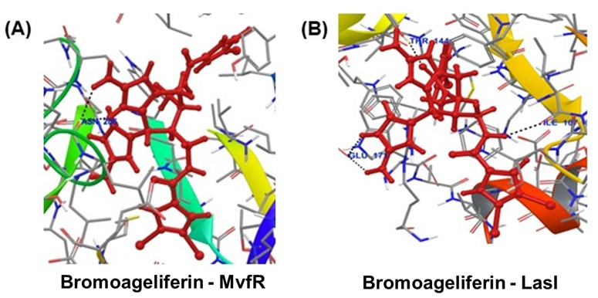

**Supplementary Figure S2:** Graphical representation of the docking poses of ageliferin bound target protein complexes based on the highest binding affinity.

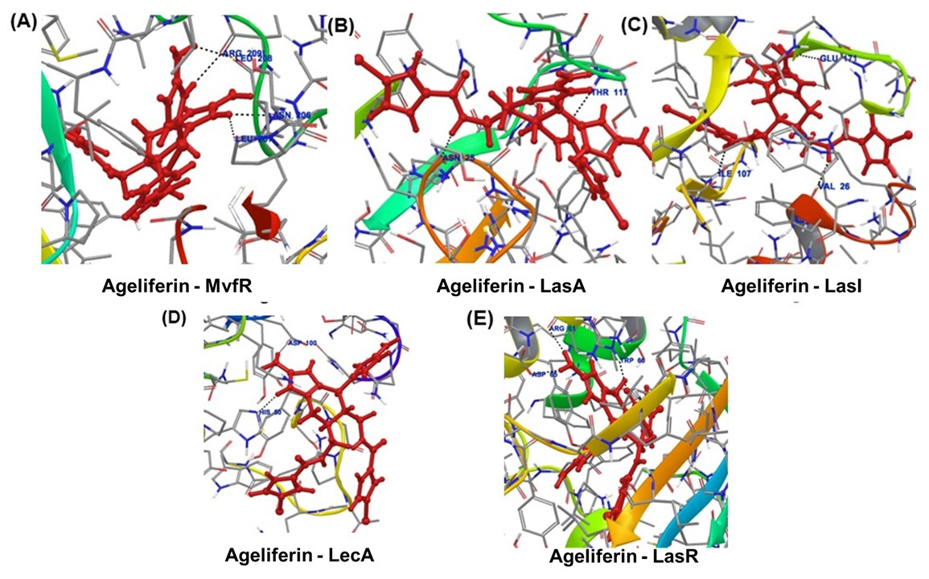

**Supplementary Figure S3:** Graphical representation of the docking poses of mauritiamine bound target protein complexes based on the highest binding affinity.

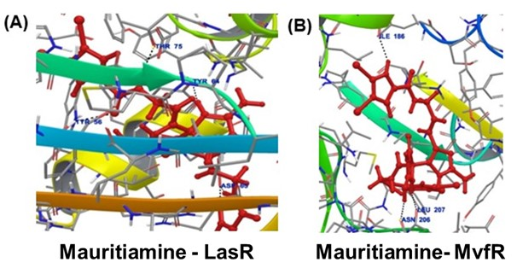

**Supplementary Figure S4:** Graphical representation of the docking poses of oroidin bound target protein complexes based on the highest binding affinity.

